Design DB Model for GUVI Zen Class

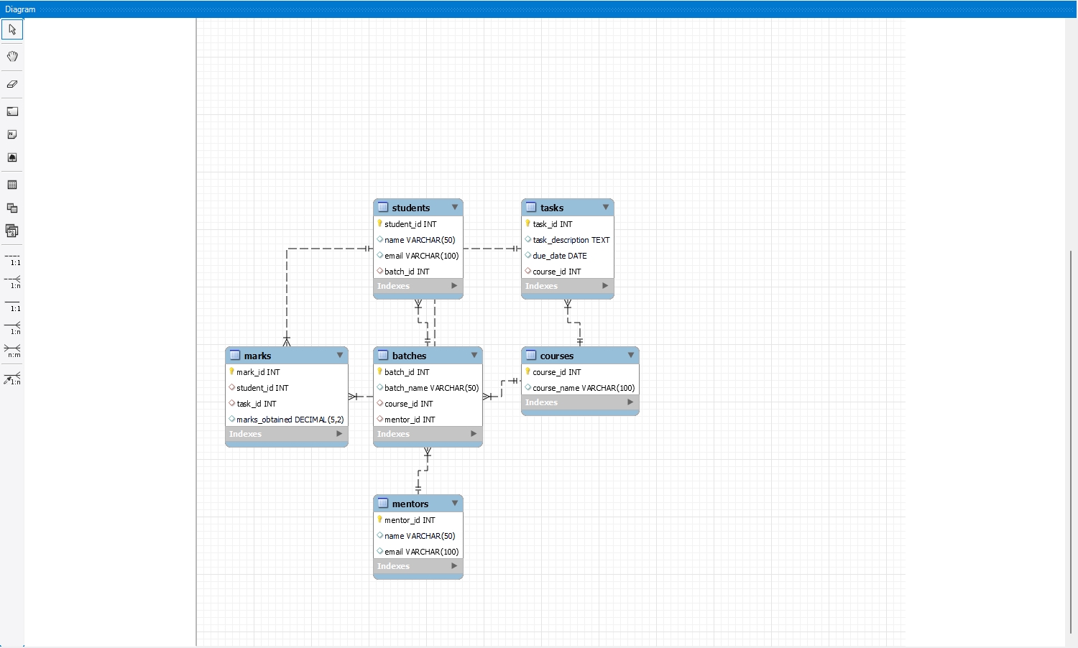

SQL Queries Used:

CREATE TABLE students (

student_id INT PRIMARY KEY,

name VARCHAR(50),

email VARCHAR(100)

);

CREATE TABLE tasks (

task_id INT PRIMARY KEY,

task_description TEXT,

due_date DATE

);

CREATE TABLE mentors (

mentor_id INT PRIMARY KEY,

name VARCHAR(50),

email VARCHAR(100)

);

CREATE TABLE courses (

course_id INT PRIMARY KEY,

course_name VARCHAR(100)

);

CREATE TABLE batches (

batch_id INT PRIMARY KEY,

batch_name VARCHAR(50),

course_id INT,

mentor_id INT,

FOREIGN KEY (course_id) REFERENCES courses(course_id),

FOREIGN KEY (mentor_id) REFERENCES mentors(mentor_id)

);

CREATE TABLE marks (

mark_id INT PRIMARY KEY,

student_id INT,

task_id INT,

marks_obtained DECIMAL(5,2),

FOREIGN KEY (student_id) REFERENCES students(student_id),

FOREIGN KEY (task_id) REFERENCES tasks(task_id)

);

ALTER TABLE students

ADD COLUMN batch_id INT,

ADD FOREIGN KEY (batch_id) REFERENCES batches(batch_id);

ALTER TABLE tasks

ADD COLUMN course_id INT,

ADD FOREIGN KEY (course_id) REFERENCES courses(course_id);